**Life Care Pharma** introduces

.

***EP CARE***

***Softgel***

Evening Primrose Oil 1000mg & Vitamin E 100mg Softgel Capsule

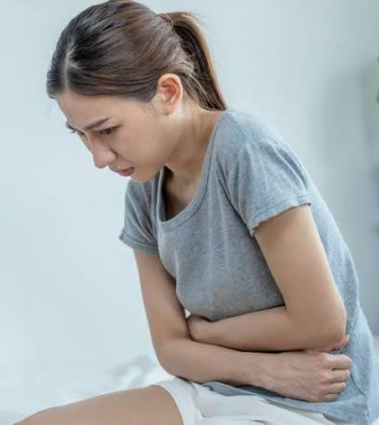

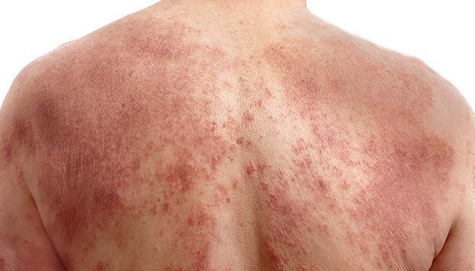 PMS **Ep Care** **96%** **Improvement in**

**Atopic Dermatitis**

Evening Primrose oil is a source of Gamma-Lepolenic Acid(GLA). GLA is an omega-6 essential fatty acid that has anti-inflammatory effects in the body. GLA promotes healthy skin & hormonal balance.

***EP Care Effective For***

* **Premenstrual Syndrome**
* **Breast Pain (Mastalgia)**
* **Dysmenorrhea**
* **Skin Disorder**
* **Atopic Dermatitis** **(eczema)**
* **Arthritis**
* **Menopause Symptoms**
* **Healthy Skin, Hair & Nails .**

[**Premenstrual syndrome (PMS)**](https://www.healthline.com/health/premenstrual-syndrome) is a monthly pattern of symptoms that start about a week before your period. These symptoms tend to go away within four days after starting your period.

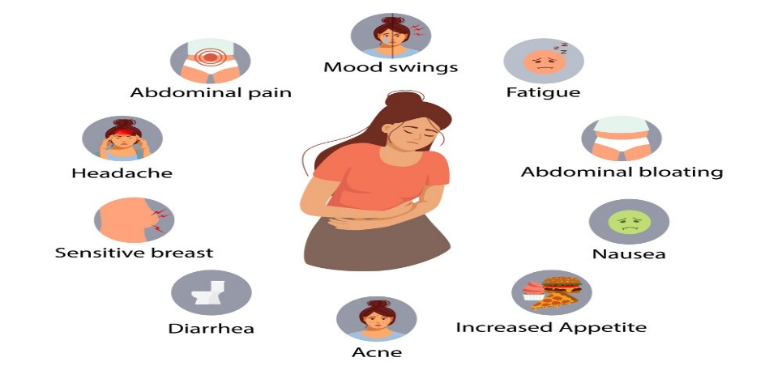For many people, PMS causes both physical and psychological symptoms, including:

* [bloating](https://www.healthline.com/health/womens-health/period-bloating)
* digestive issues
* [headaches](https://www.healthline.com/health/hormonal-headaches)
* [breast tenderness](https://www.healthline.com/health/breast-premenstrual-tenderness-and-swelling)
* mood swings
* irritability
* anxiety
* insomnia
* depressed mood

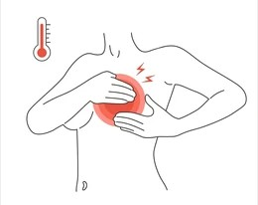About 80% women are suffer for [Premenstrual syndrome (PMS)](https://www.healthline.com/health/premenstrual-syndrome). Some people also experience a more severe form of PMS called [premenstrual dysphoric disorder (PMDD)](https://www.healthline.com/health/womens-health/pmdd-natural-treatment). People with PMDD experience at least five of these symptoms. The symptoms are often incredibly intense and get in the way of day-to-day activities. EP Care is one of the best supplements for helped to reduce symptoms of PMS.

**Mastalgia** refers to a common breast pain that a female suffers from

during her lifetime. Approximately two-thirds of women develop this pain

during their reproductive life and seek medical attention either because

it adversely affects their daily life or out of the fear of any serious underlying

pathology like breast cancer. The breast pain ranges from mild to severe.

EP Care is more effective supplements for helped to reduce breast pain.

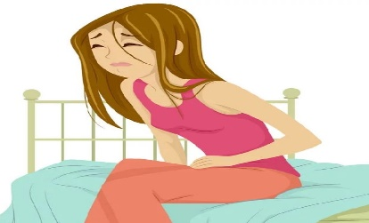**Dysmenorrhea** is defined as pain during the menstrual cycle. The pain is usually located in the lower abdomen and may radiate to the inner thighs and back.

It is a very common gynecologic problem and can

negatively impact a patient's life.it can lead to

backache, headache, bloatedness, mood swings etc.

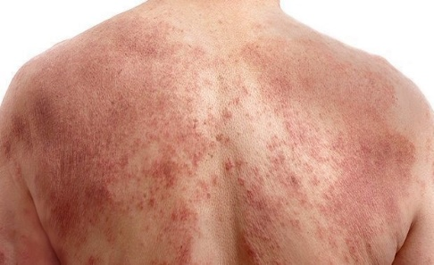**Atopic dermatitis** most often occurs where the skin flexes — inside the elbows, behind the knees and in front of the neck. Atopic dermatitis (eczema) is **a**

**condition that causes dry, itchy and inflamed skin**.

It's common in young children but can occur at any age.

**Ep Care** **96%** **Improvement in Atopic Dermatitis .**

Dosage Guideline: 1Tablet twice a day after meal for 3 to 6 months

Ref:

* https://www.healthline.com/health/evening-primrose-oil <https://www.healthline.com/health/food-nutrition/vitamin-b-complex#benefits>
* Olawaiye A, Withiam-Leitch M, Danakas G, Kahn K. Mastalgia: a review of management. J Reprod Med. 2005 Dec;50(12):933-9. [[PubMed](https://pubmed.ncbi.nlm.nih.gov/16444894)]
* Vieira BL, Lim NR, Lohman ME, et al. [Complementary and alternative medicine for atopic dermatitis: an evidence-based review.](https://www.ncbi.nlm.nih.gov/pubmed/27388911) American Journal of Clinical Dermatology. 2016;17(6):557-581.